Venous Blood Gas (VBG)

If information about a patient’s ventilation and oxygen status is required, then an arterial blood gas (ABG) is ordered. If only information about the patient’s ventilation status is required, then a venous blood gas (VBG) can be ordered. There are less risks involved with drawing from a vein versus drawing from an artery.

Who can draw these?
- RNs – from PIV or central lines
- Phlebotomist
What do you need?
- Same items that you would need to draw from a central line.
  - Vacuette, empty 5cc syringe, 3 flushes (one for before the draw and 2 for after), alcohol swab, patient label
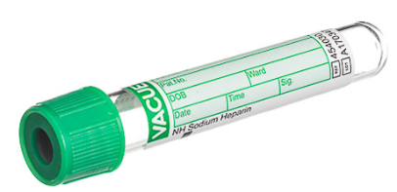
  - Plain Green top blood tube

Process:
- Obtain your sample and place label on tube (after 2 patient verifications done)
- Notify ICU RT via Voalte that you will be sending them the sample and what the patient’s respiratory rate (RR) is.
  - You do not need to fill out the green card, but can if you want (just need the RR on it)
- Tube sample (ON ICE) to tube station 520

