Specimen Collection Swabs and Usages
Swab | Product Name | Test Description(s)
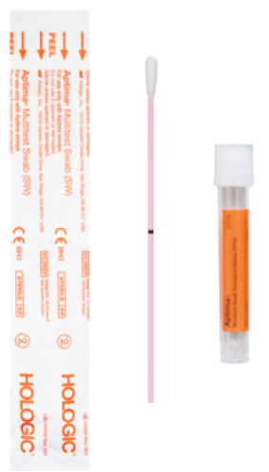 | Aptima MultiTest Swab(Self-Collect)  Order #: 63528  Should be used for the following approved sources:  - Vaginal  - Throat/Pharynx  - Oropharynx  - Anal/Rectal  - Penile Meatal | - Chlamydia/Neisseria  - Chlamydia  - Neisseria  - Mycoplasma genitalium (vaginal, penile/meatal) (Mayo)**  - Trichomonas (For women, order test code 9008. For men, order test code 6846 to Mayo Clinic Laboratories)
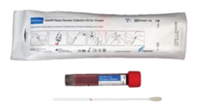 | Cepheid Collection Kit  Order #: 62520 | - Covid Only – SARS CoV-2 PCR  - 4-plex – SARS CoV2/Flu A-B/RSV  - PCR Upper Respiratory Panel
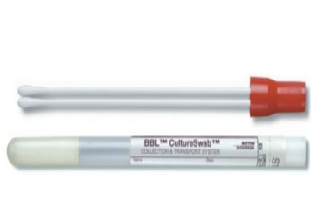 | Culturette Aerobic  (Red Top Swabs)  Order #: 02086866 | - Culture, Wound or Abscess  - Culture, Throat  - Culture, Throat Strep Only  - Culture, Nose  - Culture, Ear  - Culture, Group B Strep Only  - Culture, Genital  - MRSA pre-Surg  - Pharm Nares PCR
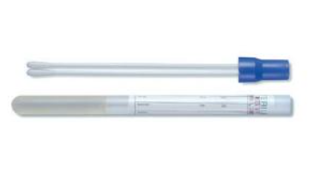 | Culturette Anaerobic  (Blue Top Swabs)  Order #: 02086868 | - Culture, Wound or Abscess Anaerobic
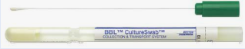 | Culturette Liquid Stuarts Single Swab, Nasopharyngeal  (Green Top Swabs)  Order #: NA | - Bordetella pertussis/Bordetella Para pertussis PCR (Mayo)
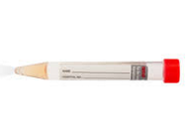 | BBL Culture Swab w/ VTM  Order #: NA | - Measles Virus, PCR, Throat
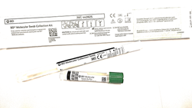 | Vaginitis Collection Kit  Order #: 70069 | - Vaginitis Panel  - (Candida, Gardnerella vaginalis, Trichomonas)
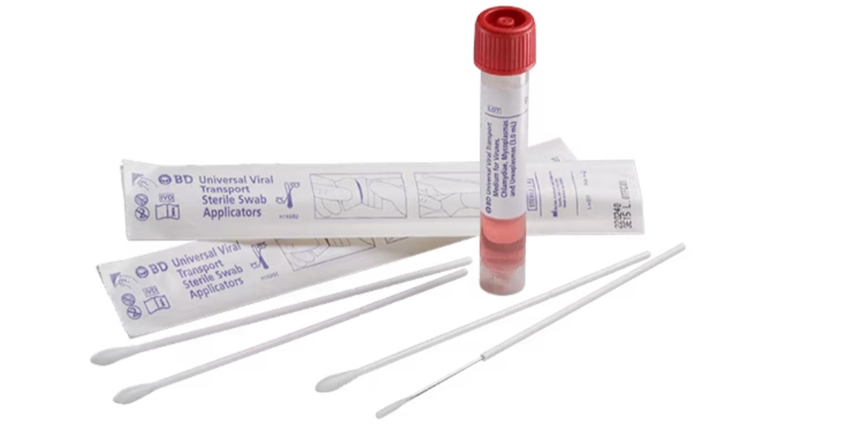 | Viral Transport Kit  Order #: NA | - HSV 1&2/VZV PCR  - Monkeypox Virus DNA (Mayo)**  - Ureaplasma PCR (URRP) (Mayo)**
**Mayo tests need its own swab.

