Specimen Collection Vials and Usages
Vial | Product Name | Test Description(s)
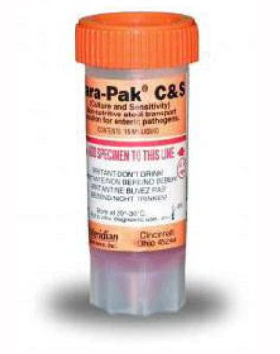 | C&S Stool Vial  Order #: 50388 | - Culture Stool Panel  - Culture Stool Campylobacter  - Culture Stool E. Coli  - Culture Stool Salmonella & Shigella  - GI Panel PCR  - H pylori + Clarithro Resist, PCR (Mayo)  - PCR Enteric Bacterial Panel
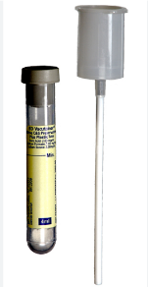 | C&S Urine Transport Kit  Order #: 60313 | - Culture Urine Only
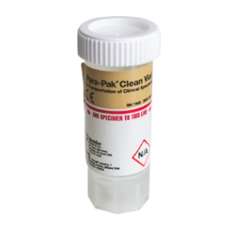 | Clean Stool Vial  Order #: 60378 | - Calprotectin (Mayo)  - Clostridium difficile  - Lactoferrin  - Norovirus  - Rotavirus Antigen, Stool  - Stool for WBCs
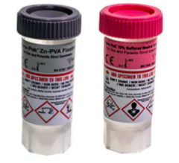 | Ova & Parasite Kit  Order #: 60381 | - Cryptosporidium Antigen, Feces  - Giardia Antigen, Feces  - Ova and Parasites Screen, Stool (Mayo)
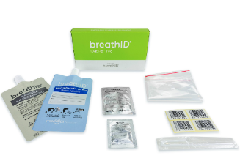 | H. Pylori Breath Kit | - H. Pylori Breath Test (Mayo)
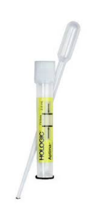 | Aptima Urine Collection Kit  (Specimen must be filled within window on vial. If not, specimen is inacceptable) | - Chlamydia, Urine  - Chlamydia/Neisseria, Urine  - Neisseria, Urine  - Trichomonas
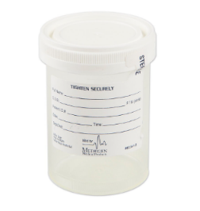 | Urine Cup-Sterile  Order #: 02068831 | - Chlamydia, Urine  - Chlamydia/Neisseria, Urine  - Neisseria, Urine  - Trichomonas  - Routine or Complete Urinalysis  - Urinalysis Micro
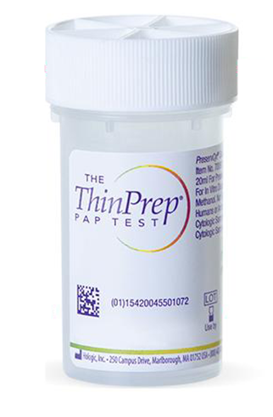 | Thin Prep Pap Vial  Order #: 60431 | - Liquid Based Pap  - HPV HR and Genotyping 16/18/45  - Chlamydia  - Neisseria  - Trichomonas

