Specimen Collection Swabs and Usages
Swab | Product Name | Test Description(s)
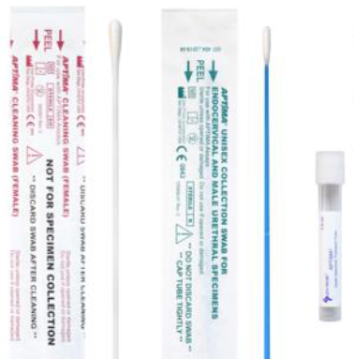 | Aptima Unisex Swab  Order #: 61737  Should be used for the following approved sources:  - Endocervical  - Cervical  - Male Urethral  *Only submit the blue swab | - Chlamydia/Neisseria  - Chlamydia  - Neisseria  - Mycoplasma genitalium  - Trichomonas (For women, order test code 9008. For men, order test code 6846 to Mayo Clinic Laboratories)
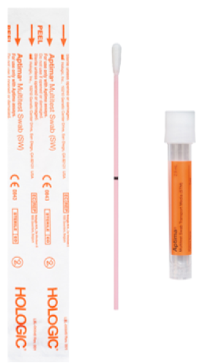 | Aptima MultiTest Swab  Order #: 63528  Should be used for the following approved sources:  - Vaginal  - Throat/Pharynx  - Oropharynx  - Anal/Rectal  - Penile Meatal | - Chlamydia/Neisseria  - Chlamydia  - Neisseria  - Mycoplasma genitalium  - Trichomonas (For women, order test code 9008. For men, order test code 6846 to Mayo Clinic Laboratories)
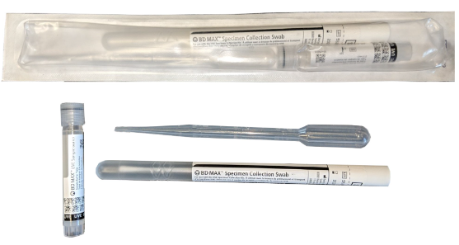 | Vaginitis Collection Kit  Order #: 70069 | - Vaginitis Panel  (Candida, Gardnerella vaginalis, Trichomonas)
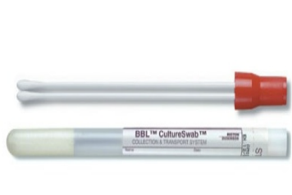 | Culturette Aerobic  (Red Top Swabs)  Order #: 02086866 | - Culture, Wound or Abscess  - Culture, Throat  - Culture, Throat Strep Only  - Culture, Nose  - Culture, Ear  - Culture, Group B Strep Only  - Culture, Genital  - MRSA Pre-Surg
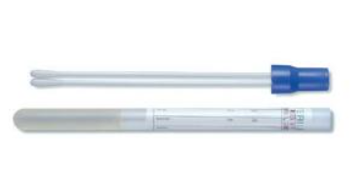 | Culturette Anaerobic  (Blue Top Swabs)  Order #: 02086868 | - Culture, Wound or Abscess Anaerobic
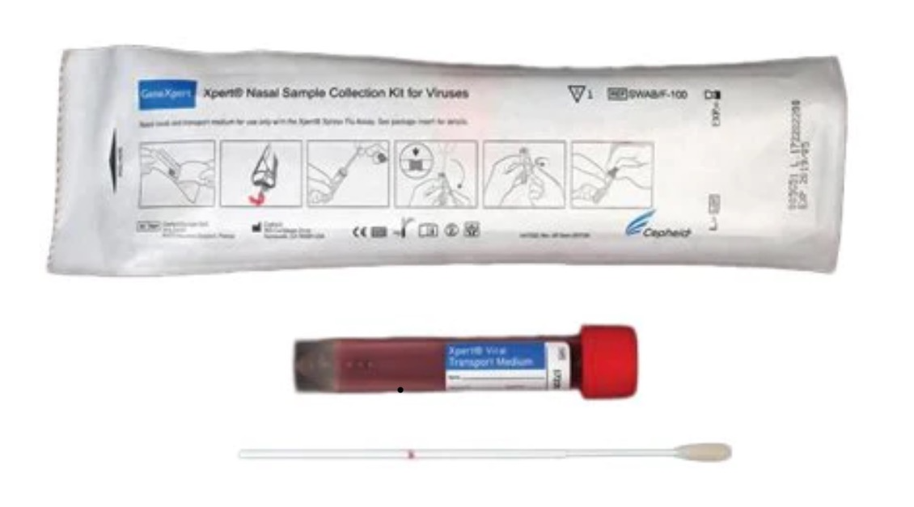 | Cepheid Collection Kit  Order #: 62520 | - Covid Only – SARS CoV-2 PCR  - 4-plex – SARS CoV2/Flu A-B/RSV  - PCR Upper Respiratory Panel
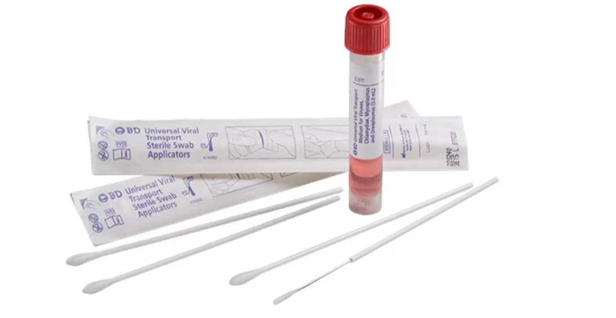 | Viral Transport Kit  Order #: NA | - HSV 1&2/VZV PCR  - Monkeypox Virus DNA

